大学院共通講義（集中講義）のお知らせ
Introduction to Nanotechnology and Nanoscience 1
Place：Meeting Room on the 1st floor in Building No.5
(Research Institute for Electronic Science) on Northern Campus
Duration: 31, July 2017 - 3, August 2017
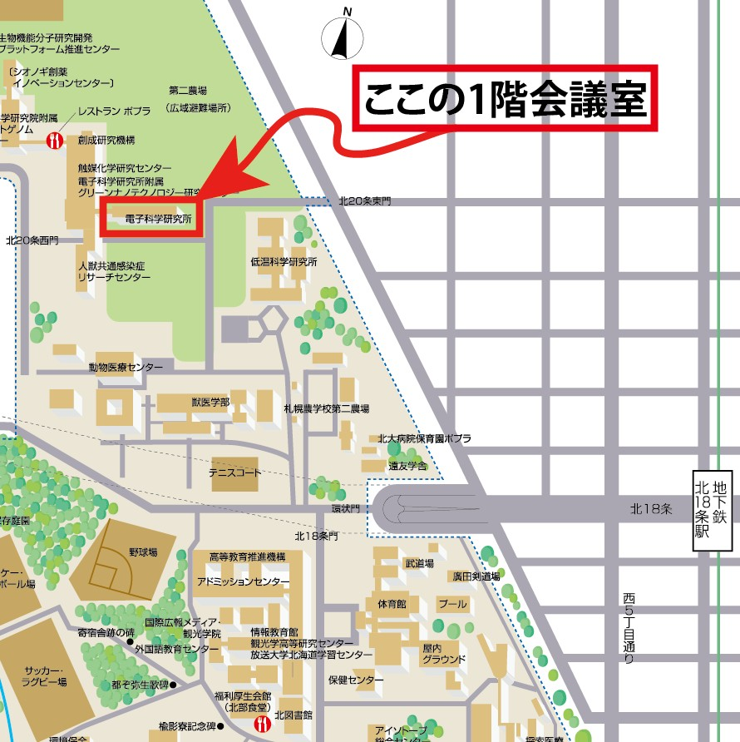
この講義はサマーインスティチュートとして開催されるため全講義が英語で行われます．

Monday 31th July
10:30-12:00 Arezki Boudaoud (The École Normale Supérieure de Lyon)
Morphogenesis: from physical to living systems I
13:00-14:30 Arezki Boudaoud (The École Normale Supérieure de Lyon)
Morphogenesis: from physical to living systems II
14:45-16:15 Bi-Chang Chen (Academia Sinica)
Fluorescence Light Sheet Microscopy Development and Applications I
16:30-18:00 Bi-Chang Chen (Academia Sinica)
Fluorescence Light Sheet Microscopy Development and Applications II

Tuesday 1st August
10:30-12:00 Jean-Paul Rieu (Claude Bernard Lyon University)
Regulation of amoeboid motility by cell-cell contacts and secreted molecules
13:00-14:30 Jason Green (University of Massachusetts Boston)
Emergence of entropy and disorder in dynamics I
14:45-16:15 Jason Green (University of Massachusetts Boston)
Emergence of entropy and disorder in dynamics II

16:30-18:00
Wednesday 2nd
10:30-12:00 Satoshi Nakata (Hiroshima University)
Nonlinear phenomena of self-propelled motors designed based on chemical information I
13:00-14:30 Satoshi Nakata (Hiroshima University)
Nonlinear phenomena of self-propelled motors designed based on chemical information II
14:45-16:15 Takashi Miura (Kyushu University)
Modeling vascular development I
16:30-18:00 Takeshi Miura (Kyushu University)
Modeling vascular development II

Thursday 3rd August
10:30-12:00 Yutaka Sumino (Tokyo University of Science)
Introduction to nonequilibrium softmatter I
13:00-14:30 Yutaka Sumino (Tokyo University of Science)
Introduction to nonequilibrium softmatter II
14:45-16:15 Makoto Sato (Kanazawa University)
Mathematical modeling and genetic analysis of the proneural wave I
16:30-18:00 Makoto Sato (Kanazawa University)
Mathematical modeling and genetic analysis of the proneural wave II

Performance will be evaluated based on reports and attendance.
Problems for reports will be assigned by each lecturer separately.
Deadline for report submission: 10th, August.
Please submit the report by E-mail after saving it as a PDF file or a Word file.
E-mail address: nagayama@es.hokudai.ac.jp.
Please avoid any non-standard fonts in the report file.
For example, use Times New Roman font or MS Mincho font.

問い合わせ先：長山雅晴（電子研）、内線3357
E-mail: nagayama@es.hokudai.ac.jp

